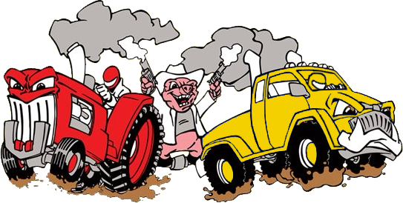
4739 S. Cypress Dr, Walnutport PA 18088 www.lorahspulls.com

Dear Neighbor,

The Lorah family has been farming in Lehigh Township for over 100 years. Growing up, going to the Tractor pulls at local fairs was a family tradition.

We began hosting tractor pulls at our farm in 2006 with one event per year, since then we have grown to 12 events per year and increased our track size to accommodate two sleds running side by side.

We have Truck pulls on Friday nights, and Garden Tractor and Farm Tractor pulls on Saturday nights. Our events draw both competitors and spectators from our surrounding counties as well as New York, New Jersey, Maryland, Delaware, and Connecticut.

We are currently seeking Sponsors for our 2018 season and would like to ask for your support. The 2018 listing of sponsorship packages are included within.

Thanks in advance for your support, our family looks forward to seeing you at the Truck & Tractor Pulls this year!

Sincerely,

Ed Lorah

4739 S. Cypress Dr, Walnutport PA 18088 www.lorahspulls.com

Sponsorship Opportunities – 2018 Season

Track Sponsor - $5000 (1 available)
- Premier 10’ X 20’ advertising on the trailer in front of the track
- (4) 2.5’ X 4’ vinyl banner’s provided to display on track fence
- 4’ X 8’ double sided banner on roller, ran over track in between all heats
- Exclusive advertising on website – including a link to your company’s website
- Company Information announced over PA minimum of 6 times
- 4 Free Admission Passes to each event

Gold Sponsor - $1500 (2 available)
- (4) 2.5’ X 4’ vinyl banner’s provided to display on track fence
- 3’ X 4’ double sided banner on scareifier, ran over track in between all heats
- Featured advertising on website – including a link to your company’s website
- Company Information announced over PA minimum of 6 times
- 4 Free Admission Passes to each event

Silver Sponsor - $500
- (2) 2.5’ X 4’ vinyl banner’s provided to display on track fence
- Featured advertising on website – including a link to your company’s website
- Company Information announced over PA minimum of 3 times
- 2 Free Admission Passes to each event

Bronze Sponsor - $250
- (2) 2.5’ X 4’ vinyl banner provided to display on the track fence
- Bronze Sponsor listing on website – including a link to your company’s website
- Company information announced over PA minimum of 3 times
- 2 Free Admission Passes to each event

*Event Sponsor I - $150
- (1) 2.5’ X 4’ vinyl banner provided to display on track fence
- Sponsor listing on website – including a link to your company’s website
- Company information announced over PA minimum of 3 times
- 2 Free Admission Passes to event of your choice

*Event Sponsor II - $50
- Company information announced over PA minimum of 3 times and 1 Free Admission Pass
*event sponsorships are for an individual event only

Sponsor Website Advertising – www.lorahspulls.com
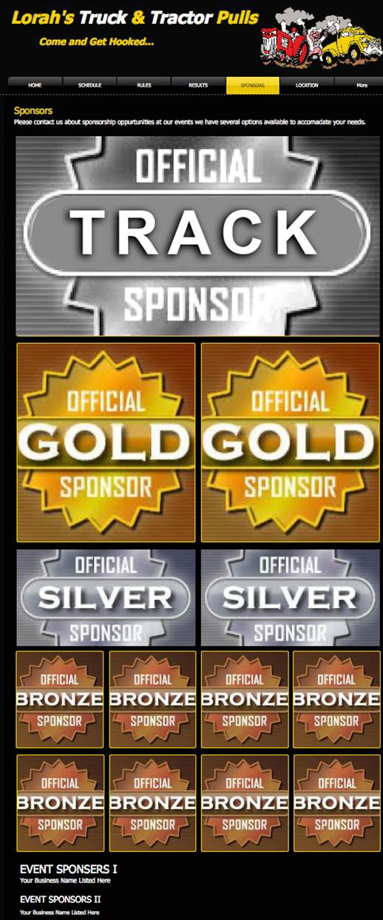

4739 S. Cypress Dr, Walnutport PA 18088 www.lorahspulls.com

Sponsor Registration Form - 2018 Season

Business Name:

Name/Title:

Address:

City: State: Zip:

Phone: Fax:

Email: Website:
*Event Sponsor I …...$150 Date:
*Event Sponsor II …..$50 Date:
*event sponsorships are for a single event only
See the enclosed sheet for a detailed description of each sponsorship opportunity
Track Sponsor ...........$5000 Gold Sponsor……….$1500 Silver Sponsor ……...$500
Bronze Sponsor ……$250
Δ
Δ
Δ
Δ
Δ
Δ
SPONSORSHIP OPPORTUNITIES (check box):

THANK YOU FOR YOUR SUPPORT!
Please mail your check payable to Lorah’s Farms, 4739 S. Cypress Drive, Walnutport, PA, 18088

